**Isolation Forest: Anomaly Detection**

1. **Core Idea:**
   * Isolation Forest operates on the principle that anomalies (outliers) are "few and different."
   * Because they are rare and have distinct feature values, they should be easier to *isolate* from the rest of the data points compared to normal points.
2. **How it Works:**
   * **Ensemble Method:** It builds an ensemble (a "forest") of multiple Isolation Trees (iTrees).
   * **Building an iTree:**
     + A random subsample of the data is selected.
     + The algorithm recursively partitions (splits) this subsample:
       - It randomly selects a feature.
       - It randomly selects a split value between the minimum and maximum values of that feature in the current data subset.
       - Data points are divided based on whether their value for the selected feature is above or below the split value.
     + This continues until each data point is isolated in its own leaf node or a predefined maximum tree depth is reached.
     + Above is the decision tree.
   * **Anomaly Identification:**
     + Anomalous points, being different, tend to require fewer random splits to be isolated. They will generally be closer to the root of the iTrees (i.e., have a shorter *path length*).
     + Normal points are more numerous and similar, requiring more splits to isolate, resulting in longer path lengths.
   * **Anomaly Score:**
     + The algorithm calculates the average path length for each data point across all the iTrees in the forest.
     + This average path length is used to compute an anomaly score, typically normalized to be between 0 and 1.
     + **Score Interpretation:**
       - Scores close to 1 indicate a high likelihood of being an anomaly (short average path length).
       - Scores significantly less than 0.5 suggest a normal data point (long average path length).
       - Scores around 0.5 indicate ambiguity.
3. **Key Parameters (Common in libraries like scikit-learn):**
   * n_estimators: The number of iTrees to build in the forest. More trees generally lead to more stable results. (Default often 100).
   * max_samples: The number (or fraction) of samples used to build each individual iTree. Controls the degree of subsampling. (Default often 'auto' or 256).
   * contamination: An estimate of the proportion of outliers expected in the dataset (e.g., 0.01 for 1%). This helps set the threshold for classifying points as anomalies vs. normal points when using the predict method. (Range (0, 0.5]).
   * max_features: The number (or fraction) of features to consider when making a random split.
4. **Advantages:**
   * **Efficiency:** Computationally efficient with low memory requirements and often linear time complexity, making it suitable for large datasets.
   * **Scalability:** Works well with high-dimensional data where distance-based methods often struggle.
   * **No Distance Metric:** Doesn't rely on distance calculations, avoiding issues related to the "curse of dimensionality."
   * **No Distribution Assumptions:** Doesn't require data to fit a specific statistical distribution.
   * **Handles Swamping/Masking:** Subsampling helps reduce the impact of masking (dense anomaly clusters) and swamping (normal points close to anomalies).
5. **Disadvantages:**
   * **Parameter Sensitivity:** Performance can be sensitive to parameter choices, especially contamination.
   * **Axis-Parallel Splits:** May not be optimal for datasets where anomaly separation requires diagonal boundaries.
   * **Interpretability:** Can be less interpretable than simpler methods ("black box" nature), although techniques exist to help explain predictions (e.g., SHAP).
   * **Local Anomalies:** May sometimes be less effective at detecting anomalies that are only outliers within a specific local region.
   * **Clustered Anomalies:** Performance might degrade if anomalies form dense clusters themselves.
6. **Common Applications:**
   * Fraud detection (financial transactions, insurance claims)
   * Network intrusion detection
   * Identifying faulty sensor data or equipment failure (predictive maintenance)
   * Detecting outliers in healthcare data
   * Data preprocessing/cleaning

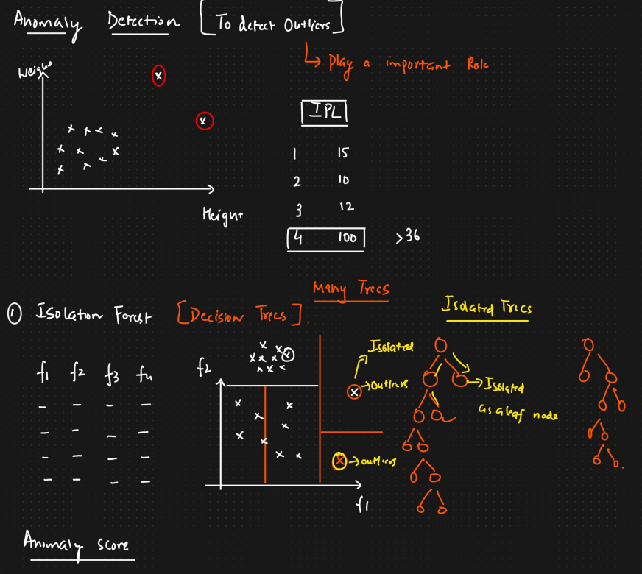

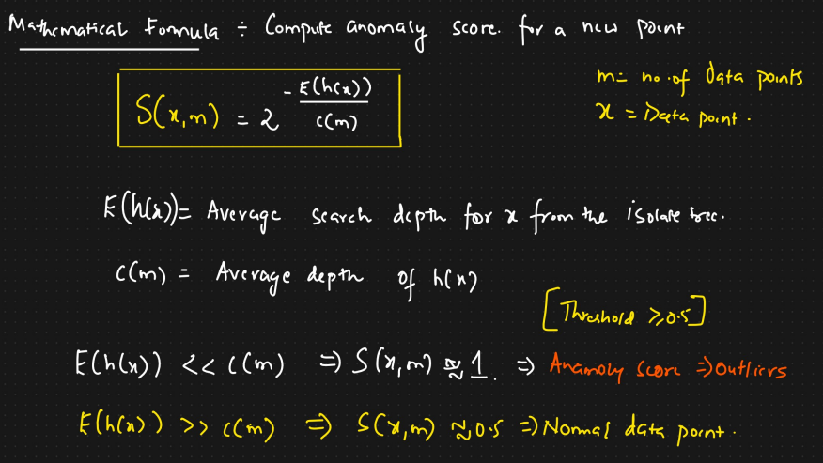

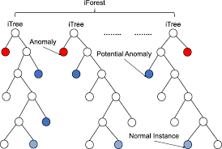

### **Local Outlier Factor (LOF): Anomaly Detection**

### **Core Idea:**

### LOF is an unsupervised, density-based algorithm that identifies outliers by comparing the *local density* of a data point to the local densities of its neighbors.

### The central concept is that an outlier will have a substantially lower density than its neighbors, whereas an inlier will have a density similar to its neighbors.

### Its strength lies in detecting outliers in datasets with varying densities, where a point might be an outlier relative to its local neighborhood but not necessarily in a global context.

### **Key Concepts & How it Works:**

### **k-Nearest Neighbors (k-NN):** For each point p, the algorithm first finds its k nearest neighbors. The parameter k (often called n_neighbors) is crucial.

### **k-distance(p):** The distance between point p and its k-th nearest neighbor.

### **Reachability Distance (reach-dist_k(p, o)):** This is defined as max(k-distance(o), actual_distance(p, o)). It's the true distance from p to a neighbor o, but it's never smaller than the k-distance of neighbor o. This helps smooth density estimates within clusters.

### **Local Reachability Density (lrd_k(p)):** This measures the local density around point p. It's calculated as the inverse of the *average* reachability distance from point p to all of its k-neighbors. A higher lrd means the point is in a denser region.

### **Local Outlier Factor (LOF_k(p)):** This is the final anomaly score for point p. It's calculated as the ratio of the *average* lrd of p's k-neighbors to the lrd of p itself. LOF_k(p) = average(lrd of neighbors) / lrd(p)

### **Interpreting LOF Scores:**

### **LOF ≈ 1:** The point p has a density similar to its neighbors (likely an inlier).

### **LOF > 1:** The point p is in a sparser region (lower density) than its neighbors (likely an outlier). The larger the LOF value, the more anomalous the point is considered.

### **LOF < 1:** The point p is in a denser region than its neighbors (can happen for points inside a dense cluster).

### **Key Parameters:**

### n_neighbors (k): The number of neighbors to use for local density estimation. This is the most critical parameter. Choosing it too small makes the algorithm sensitive to noise; choosing it too large can blur the locality. A common starting point is 20, but tuning is often needed.

### metric: The distance metric used to measure distances between points (e.g., 'euclidean', 'manhattan', 'minkowski').

### contamination (used in libraries like scikit-learn): An estimate of the expected proportion of outliers in the dataset. This helps set a threshold on the LOF scores to classify points as outliers (-1) or inliers (1).

### algorithm: The algorithm used to compute nearest neighbors ('auto', 'ball_tree', 'kd_tree', 'brute').

### novelty: A parameter (e.g., in scikit-learn) to switch between outlier detection (finding anomalies in the training data) and novelty detection (using the trained model to find anomalies in *new*, unseen data).

### **Advantages:**

### **Effective in Varying Densities:** Excels where global methods might fail because it considers local context.

### **Unsupervised:** No need for labeled data.

### **Provides Scoring:** Gives a score indicating the *degree* of outlierness, not just a binary label.

### **Well-Established:** A widely studied and often effective density-based approach.

### **Disadvantages:**

### **Computational Complexity:** Calculating distances and neighbors for all points can be computationally intensive (potentially O(n²) without optimizations, or O(n log n) with spatial indexing), making it slower for very large datasets.

### **Parameter Sensitivity:** Performance is highly dependent on the choice of k (n_neighbors).

### **Curse of Dimensionality:** Like other distance-based methods, its effectiveness can decrease in high-dimensional spaces as distances become less meaningful.

### **Score Interpretation:** While >1 indicates an outlier, the magnitude can vary between datasets and parameter settings, making thresholding difficult without the contamination parameter or domain expertise.

### **Common Applications:**

### Intrusion detection in networks.

### Fraud detection.

### Identifying anomalies in geographic data or video streams.

### Data cleaning and preprocessing.

